**Circuit description:**

A credit card sized circuit (thickness as small as possible) that when it is near another card (if they are in a Bluetooth range) and detects audio (through a microphone), will record the audio on a SD card. Also, the device should be able to plot the movement the user has made with an accelerometer/gyroscope/magnetometer.

**Main task:**

Design a PCB with these main components:

* MCU: [Atmega328 (TQFP)](https://www.digikey.com/product-detail/en/microchip-technology/ATMEGA328PB-ANR/ATMEGA328PB-ANRTR-ND/5638752), it will be programmed externally.

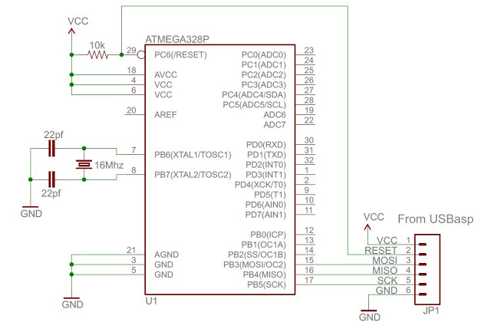

* Charging circuit with the [TP4056](https://lcsc.com/product-detail/PMIC-AC-DC-Converters_TP4056M_C21417.html), [DW01A](https://www.sunrom.com/p/dw01a-sot23-6-lithum-battery-protection-ic) and [FS8205A](https://lcsc.com/product-detail/MOSFET_FS8205A_C16052.html).

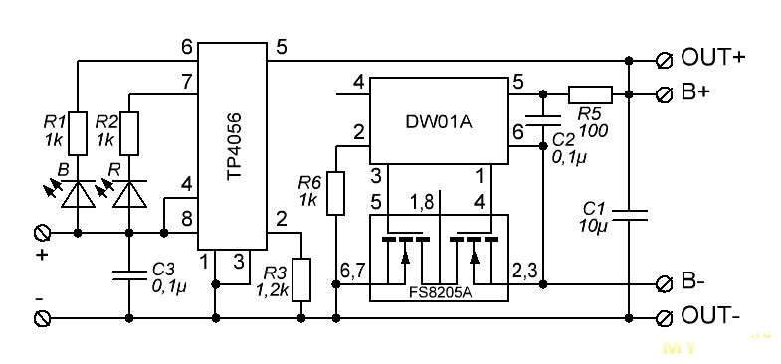

Exclude the LEDs in final design to save power. The resistor from TP4056 must comply with the charging current from the used battery. Recommended battery: [PRT-13854 (850mAh)](https://www.digikey.com/product-detail/en/sparkfun-electronics/PRT-13854/1568-1495-ND/6605201).

* Audio: [CMC-5042PF-AC](https://www.digikey.com/product-detail/en/cui-inc/CMC-5042PF-AC/102-1724-ND/1869984) is recommended with the [MAX9814](https://www.digikey.com/product-detail/en/maxim-integrated/MAX9814ETD-T/MAX9814ETD-TCT-ND/2037128) amplifier. The inverted OUTPUT pin goes to an ADC pin on the MCU, for example, the ADC0/pin 23.

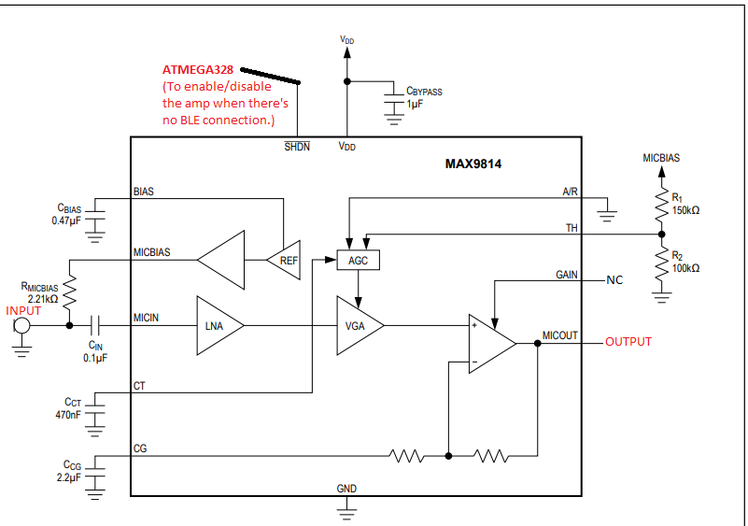

* MicroSD card: Besides the card mount, this will need a **3.3V regulator** (like the [LM1117MPX-3.3/NOPB](https://www.digikey.com/product-detail/en/texas-instruments/LM1117MPX-3.3-NOPB/LM1117MPX-3.3-NOPBCT-ND/1010516)) and a **bidirectional logic level translator** such as the [ADG3304](https://www.digikey.com/product-detail/en/analog-devices-inc/ADG3304BRUZ-REEL7/ADG3304BRUZ-REEL7TR-ND/2342667) for between the SCK, CS, MISO and MOSI pins and the microcontroller SPI pins.

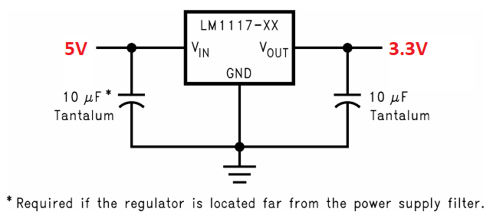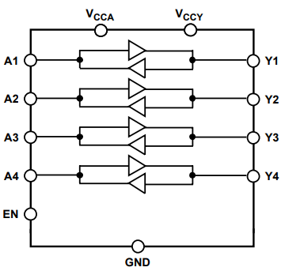

* Bluetooth: Either [CYBLE-012011-00](https://www.digikey.com/product-detail/en/cypress-semiconductor-corp/CYBLE-012011-00/428-3537-1-ND/5873454), [CYBLE-012012-10](https://www.digikey.com/product-detail/en/cypress-semiconductor-corp/CYBLE-012012-10/428-3538-1-ND/5873455) or the [CYBLE-022001-00](https://www.digikey.com/product-detail/en/cypress-semiconductor-corp/CYBLE-022001-00/428-3408-1-ND/5355485) is fine. Given that these may work on **3.3V** it can share the previous regulator described. These modules may have several communication protocols like SPI, I2C and UART.

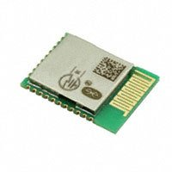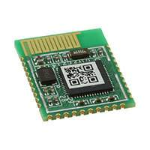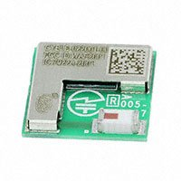

* Accelerometer/gyroscope/magnetometer: [LSM9DS1TR](https://www.digikey.tw/product-detail/en/stmicroelectronics/LSM9DS1TR/497-14946-1-ND/4988079), which communicates with either SPI or I2C. This device may share the 3.3V regulator previously described. The following image is the application hint as described by the datasheet:

